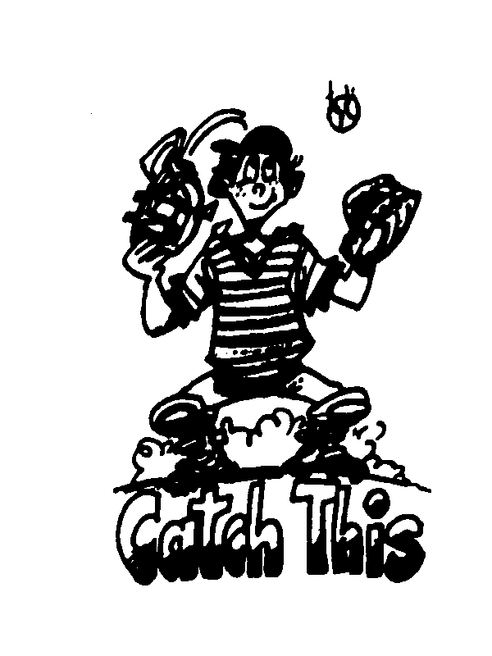 CBCA Newsletter 

Fall 2024

CBCA Activity Summary of 23-24

The CBCA awarded more than $15,000 in scholarships to graduating seniors from member schools.

We honored some very special coaches for the Hall of Fame and Assistant Coach Awards.

The CBCA awarded and distributed about 160 certificates to All CIF second team members from the Southern Section.

2024 CBCA Honorees

Assistant Coach of the Year

David Rodriguez…Yuba City HS…has coached high school baseball at Yuba City HS for 32 years. He has coached at all three levels of high school baseball. During his tenure as the varsity head coach, Coach Rodriguez won 7 league Championships and 2 Sac-Joaquin Section titles. He has complied 237 wins and was selected as League Coach of the Year three times. In 2020 he was named the State of California High School Coach of the Year.
A leader and mentor, Coach Rodriguez has had 13 former players sign MLB contracts and over 45 players continue their baseball careers collegiately.
Additionally, he hosted various baseball community events, coaching clinics, parent baseball seminars, umpire clinics and has donated his time and facilities to the community. His players were frequently involved in and around the community and in 2014 they earned the CIF-Sac Joaquin Section Community Service Award. Periodically Dave volunteers his time at San Quentin Prison teaching life lessons through baseball.
In 2023 Yuba City High School honored Coach Rodriguez by retiring his number “4”.

Hall of Fame

Gary Remiker…Cathedral Catholic HS... Gary is in his 24th season as head coach at Cathedral Catholic HS. His teams have won over 500 games with 12 league titles and 8 CIF-San Diego Section championships. He was named District 8 Coach of the Year by the ABCA and State Coach of the Year by Cal Hi Sports. His work with the San Diego Coaches Association is remarkable. He has served as the group’s secretary/treasurer for 20 years. His work with the SDBCA has greatly helped the CBCA grow its membership.

Eric Lay…Colusa HS…Eric has been a head coach for 24 years with the past 12 at Colusa HS. His teams have won over 550 games and 18 league titles. He has won a remarkable 11 CIF-Northern Section championships in his 24 seasons. He has been honored as CIF-NS coach of the year 3 times, 2021 Cal HI Sports State (small school) Coach of the Year in 2021, and State Coach of Year in 2022. His other activities include serving a Little League volunteer the past 14 years, serving as CIF-NS advisory committee member for the past 17 years and as volunteer for the City of Colusa recreation department.

Michael Mitchell…SD Catholic HS…Mike has coached baseball for 42 years. His 29 years as head coach at Christian HS have seen his teams win 5 CIF-titles and 3 runners-up. With over 600 wins to go along with this titles, he was named by Cal Hi Sports as State Coach of the Year in 2017. His team was named state champs that year and also in 1997 for medium size schools.

Tom Dill…Notre Dame HS..In 32 years at Notre Dame, Tom has won 10 league titles with 1 CIF-Southern Section title to go with over 550 wins.
His work at ND has resulted in over 100 college players and 40 professional players. Two of his former players have been featured on the cover of Sports Illustrated, Giancarlo Stanton and Hunter Greene. In 200 and 2008, Tom coached the Cambodian National team.

Rick Weber…Viewpoint HS..Rick is serving his 6th season as head coach at Viewpoint. In his 42 years as a varsity head coach at Viewpoint and 5 other schools, he has amassed close to 700 wins. A rival coach stated “Rick Weber is a coaches coach and an example of what a high school coach should prioritize: Work-life balance, Coaching the , in the well-being of young people, Knowing the rules, Modeling integrity. I cannot think of anyone I respect more who has been across the field than me.”

Rick Prieto…Culver City HS…Rick has been the head coach at Culver City for 28 seasons. During that time, his team has won over 400 games with 5 league titles. More importantly, his influence in the Westside LA area has been tremendous. He has decades - generations worth of scholar-athletes who will tell you that Rick Prieto is one of their most incredible mentors and influences. He hosted the Little League Challengers program at CCHS with his players serving as “buddy’s” for the participants. He won the CIF-SS Champion for Character Award in 2022.

Justin Machado…in 26 years as La Costa Canyon HS head coach, Justin’s teams have won over 600 games, 13 league titles and 5 CIF-San Diego Section championships. He was honored in 2003 and 2023 as CIF-SD Coach of the Year, 2022 Cal Hi Sports State Coach of the Year, in 2019 as a Hall of Fame honoree by the San Diego High School Sports Association, and was named 2003 National Coach of the Year by the NHSCBA.

Seeking Coach Honorees
Every June, the CBCA would like to honor several coaches for their long time (25 years) contributions to high school baseball in California. We are seeking nominations of an assistant coach and two head coaches who have not been honored yet (see honorees page at calbca.com).

These nominees should be coaches who have made significant contributions to the high school and their community.
Please submit any suggestions to inovick@aol.com, asap.

Rawlings
Rawlings is our ONLY sponsor.
Without their support, the CBCA would not be able to maintain the programs we offer players and coaches around the state.
Rawlings has supported high school baseball for over 25 years in California.
Please use Rawlings when purchasing this year. More info can be found on our website.
Scholarship Dilemma Continues
In May, we notified via email each paid member of the CBCA (apprx. 100) that we would awarding one senior from his school with a no strings attached scholarship. Amazingly, only 43 coaches responded with the information needed to send the award to the players’ families.
I am sure that some coaches did not receive the email because their school district rejected the email as spam and others had addresses that were invalid.
Please use only your personal email addresses on all our forms to prevent this situation from occurring again.

California Baseball Coaches Association
Membership Form
2024-25

Fee: $20. Make Checks payable to C.B.C.A.
To join and pay by credit card or PayPal, go to our website at Calbca.com and use the link to our google signup.

Mail to: Iran Novick
4495 Ave. de los Arboles
Yorba Linda, CA 92886

Name (print) ______________________ School_______________________

Circle State CIF Section: Southern, LA, San Diego, Northern, Central, Central Coast, Sac-Joaquin, North Coast, Oakland, SF

Home address__________________________City,zip_______________

Cell Phone ( )______________________

Your personal…Non school e-mail address
(print very carefully)___________________________________________________
Please do NOT use your school based email address. All CBCA communications will be done through this email address. Most districts have screened out our emails.

# yrs as coach _____

Hall Of Fame Nominees and schools _____________________________________
Check calbca.com to see if previously honored.

Assistant Coach Awards for Long time service _____________________________

If you use our website to join, you can pay using your paypal account or charge card by clicking the button on our home page calbca.com…

CBCA Partners with CoachComm
The CBCA has recently partnered with CoachComm.
CoachComm is now the Official On-Field Communication System of the CBCA!

If you plan to take advantage of the NFHS rules allowing one way communication with your catcher, CoachComm is our partner.

CoachComm is giving a free second catcher receiver device to any CBCA coach purchasing one of their systems.

FLEXIBLE & EASY-TO-USE COACH-TO-CATCHER COMMUNICATION

Cobalt PLUS communication technology is being used by hundreds of top collegiate teams to promote flexible, interruption-free coach to catcher communication and player development. It’s also now approved for use at the high school level! Coaches and catchers can engage in one-to-one communication and benefit from unique feedback and instruction.

System Highlights:
- Simple and easy-to-use
- Keeps pitch calls private and secure with earpiece and encrypted digital audio.
- One-time purchase with no annual fees or leases
- Talk to your catcher as much as you like and provide continuous feedback.
- Expandable! - Add additional receivers as needed.
- No licensing or frequency coordination required.
- Two-year warranty.
- Trusted name in coaching communications for more than 30 years

FOR A LIMITED TIME, TAKE ADVANTAGE OF AN EXCLUSIVE OFFER FOR CBCA COACHES!
- BUY A COACH-TO-CATCHER SYSTEM AND GET AN ADDITIONAL PLAYER RECEIVER & EAR PIECE FREE* (A $650 VALUE)

Visit the CoachComm website for more info: www.coachcomm.com/baseball

You can also contact CoachComm via email or phone.
EMAIL: sales@coachcomm.com
PHONE: 1.800.749.2761
Hurry! This offer expires November 15, 2024.

NHSBCA Reminders
The National HS BCA convention and Clinics is set for December 5-8 in Fort Meyers, Florida. The NHSBCA offers liability insurance with membership. Other membership perks include numerous awards, a Hall of Fame. For more information, goto baseballcoaches.org.

